Warning – Ceramic Brake Wear Out 2015 S550 SVT Specific - CGEA 1.3

Functional Description

The purpose of the ceramic brake wear out warning is to inform the customer that their ceramic brake pads have worn out. This warning is required because unlike standard brake pads, the ceramic brake pads do not have wear strips to give the operator an audible warning upon the brake pads being worn out. Per regulation an audible or visual indication of a brake pad wear out condition must be provided.

This feature is specific to 2015 S550 SVT and is currently not expected to be implemented on any other program. Upon this warning being displayed the red brake telltale will also illuminate (see Brake Telltale 2015 S550 SVT Specific STSS). This warning provides clarifying information as to why the red brake telltale is illuminated.

The Ceramic Brake Wear Out Warning correlates the BrkPadMsgTxt_D_Rq signal and the Operational_Mode to determine when to display the warning.

Interfaces

Interface Context Diagram (I/O Block Diagram)

Figure 1 Warning – Ceramic Brake Wear Out Warning Function Context Diagram

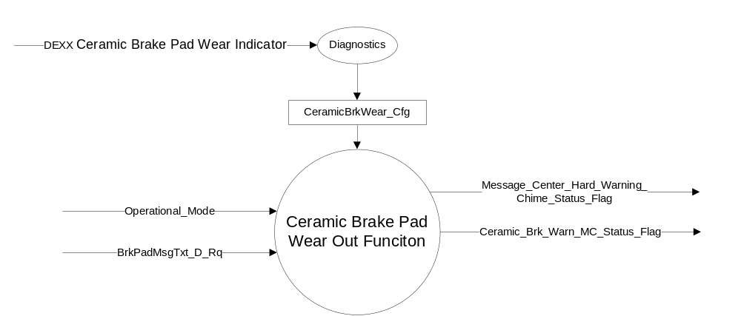

Inputs
      - INTERNAL:
            - Operational_Mode
            - CeramicBrkWear_Cfg
- MUX message from the CAN bus

- BrkPadMsgTxt_D_Rq Signal
Signal Name | Size (bits) | Detail | Units | Res. | Offset | State  Encoded | Min | Max
BrkPadMsgTxt_D_Rq | 1 |  | SED | 1 | 0 |  | 0 (0x0) | 3 (0x3)
 |  | Null |  |  |  | 0x0
 |  | Replace Pads |  |  |  | 0x1
 |  | PadsOk |  |  |  | 0x2
 |  | Faulty |  |  |  | 0x3

Outputs
Ceramic_Brk_Warn_MC_Status_Flag that is used to control the Warning displayed in the message center.
Message_Center_Hard_Warning_Chime_Status_Flag

Function/Performance

Operational Modes

Mode | Differentiating Vehicle Conditions
Sleep Mode | Inactive
Limited Mode | Inactive
Normal Mode | Ceramic Brake Wear Out Warning Message Active/Inactive
Crank Mode | Ceramic Brake Wear Out Warning Message Active/Inactive

Voltage Levels

Refer to the Cluster Features Table located in the Operational Modes and Voltage Range Strategies Section of this SPSS.

Human-Machine Interface

Visual

Indicator Graphics / Display Format
Reference the following Message IDs in the Text Message List file for the appropriate display: W3278

1.3.3.1.2 Indicator Color Coordinates

Reference section COLOR & ILLUMINATION REQUIREMENTS (GRAPHICS)

1.3.3.1.3 Indicator Characteristics

Refer to Message Center X Display_Y Button Interface Section, where X and Y are appropriate values in this document.

Audio

As Per Table 1.2

Switch Control Logic

Consumer access to Message Center Warnings shall be as specified in the Message Center X Display_Y Button Interface Section, where X and Y are appropriate values in this document.

System Accuracy

The state of the message center flags shall change within 100 msec of a state change as indicated in the state matrix found in section 1.3.5.1 of this document.

Operation: Performance and Functional

Subsystem Algorithm Flowchart / State Diagram

- State Matrix for Ceramic_Brk_Warn_MC_Status_Flag
Operational Mode | CeramicBrkWear_Cfg | BrkPadMsgTxt_D_Rq Signal | Ceramic_Brk_Warn_MC  _Status_Flag
Normal or Crank | Enabled (0x1) | 0x1 (Replace Pads) | Active
All other Cases |  |  | Inactive

- Ceramic_Brk_Warn_MC_Status_Flag to MC Warning Message ID
Ceramic_Brk_MC_Warn_Status_Flag | MC Message ID | Active Chime_Satus_Flag
Active | W1349 | Message_Center_Hard_  Warning_Chime_Status_Flag

Operation Description (supports algorithm flowchart /state diagram)

- For definition of how the Message Center arbitrates and displays Active warnings, see the Message Center – X Display with W Button Interface section of this SPSS (where X and W are appropriate values in this document).

Function Safety Classification (EMC)

Class B

Memory Storage

Parameter Name | Description | Value at  Battery Connect | Value at  Module Wake-up
Ceramic_Brk_Warn_MC_Status_Flag | Used to control the state of the warning to the Message Center arbitrator | Inactive (0x0) | Inactive (0x0)
BrkPadMsgTxt_D_Rq Signal | Input CAN Signal from the VDM | Null (0x0) | Null (0x0)
CeramicBrkWear_Cfg | State Indicator for feature presence controlled via CAN at EOL at VO plant. Defaulted to DISABLED at supplier manufacturing. | Use Stored Value | Use Stored Value
Operational_Mode | 4 state indicator for cluster operational mode | Limited | Limited or Normal or Crank
Message_Center_Hard_Warning_  Chime_Status_Flag | Used to control the state of the chime to the Chime Arbitrator | Inactive | Inactive

Prove Out

No.

Reconfigurable Telltale

No.

Message Center Msg

As per Table 1.2

Error Handling

Missing Message/Undefined Data Strategy

The signals will be declared missing as per the Diagnostics section of this SPSS.

DTCs states and history will be determined as per the Diagnostics section of this SPSS.

Diagnostics

Self Test

None

Engineering Test Mode

Not Applicable

Part II Performance

Supported Diagnostic None

Supported Diagnostic Trouble Codes (DTCs)

DTCs shall be logged as per the diagnostic section of this SPSS.
DTC | Description
C12200 | Lost Communication with Vehicle Dynamics Module

DID DExx
Block  Num | Block Description | Byte(s) | Bits | State: Description | "0" | "1" | Default | Comments/  Information
PACKETED BLOCKS
$xx | Option Content (B&A) | * | * | Ceramic Brake Pad Wear Indicator | Disabled | Enabled | Disabled | Feature enabled only for S550 SVT with Ceramic Brake Pads  Not Dealer Configurable
*Byte and bit location to be identified in Part II Specification for this cluster

Reference Specification

IS-0001 WARNINGS/INDICATORS/DISPLAYS PROVEOUT
IS-0052 OPERATING VOLTAGES - FUNCTIONAL/PERFORMANCE
IS-0069 FUNCTIONAL IMPORTANCE CLASS
IS-0324 WINDSHIELD & OTHER REFLECTIONS
IS-0327 WARNING INDICATOR EVALUATION
IS-0379 NORTH AMERICAN WARNINGS AND INDICATORS STRATEGY

IL-0017 TELLTALE AND INTERIOR ILLUMINATION – COLOR AND INTENSITY
IL-0019 GENERAL ILLUMINATION DIMMING
IL-0021 CRAFTSMANSHIP – DISPLAYS
IL-0022 GENERAL ILLUMINTATION COLOR
IL-0023 CLARITY/LEGIBILITY/READABILITY/VISUAL CONTRAST
IL -0043 OPERATIONAL ENVIRONMENT FUNCTIONALITY
IL -0045 COLOR
IL -0047 TELLTALE, INDICATOR AND DISPLAY LIGHT INTENSITY
IL -0048 ILLUMINATION ACCEPTABILITY

03-0661 PLACEMENT: CONTROL AND DISPLAY LOCATIONS
03-0662 PLACEMENT: LOGICAL GROUPING FUNCTION AND USAGE
03-0664 PLACEMENT: DOWN VISION TO COMPONENTS WITH HIGH VISUAL DEMAND
03-0665 PLACEMENT: EXPECTED LOCATIONS OF CONTROLS AND DISPLAYS VDS
03-0670 INTERIOR VISIBILITY
03-0671 INTERIOR VISIBILITY: REFLECTIONS FROM COMPONENTS & SURFACES
03-0672 INTERIOR VISIBILITY: REFLECTIONS IN DISPLAYS
03-0673 INTERIOR VISIBILITY: VISUAL OBSCURATIONS
03-0674 INTERIOR VISIBILITY: ILLUMINATION CONTROLS / DISPLAYS
03-0675 INTERIOR VISIBILITY: VEILING GLARE
03-0677 INTERIOR VISIBILITY: SUNLIGHT WASHOUT
03-0681 IDENTIFICATION: CHARACTER AND SYMBOL SIZE
03-0682 IDENTIFICATION: LEGIBILITY
03-0685 IDENTIFICATION: SYMBOLS, ABBREV FOR CONTROL
03-0721 LOGIC OF OPERATION: OPERATIONAL STEREOTYPES
03-0722 LOGIC OF OPERATION: INTERPRETATION
03-0723 LOGIC OF OPERATION: USE OF SYSTEMS WITH VISUAL DISPLAYS

Revision History

SPSS Module Revision History

Revision Level | Name | Change Description | Date
1.0 | J.Blatchford | Initial Release (Feature owner Mike Mackled) – Waiting on Released Signal | 12/3/13
1.1 | J.Blatchford | 1.5.3: Added note that Ceramic Brake Pad DID DExx is not dealer configurable. | 12/3/2013
1.2 | Ilopezla | This Update is to inform which Chime Status Flag is associated with this warning (all changes are highlighted in light blue)  Section 1.2.1 Figure 1 Added-  Message_Center_Hard_Warning_Chime_Status_Flag  Section 1.2.3 Added Message_Center_Hard_Warning_Chime_Status_Flag  Section 1.3.5 Updated Table 1.2  Changed column’s title from “Chime” To “ Active Chime_Status_Flag”  Changed “Message Center Hard Warning” to “Message_Center_Hard_Warning_Chime_Status_Flag”  Section 1.3.5.4 Added- Message_Center_Hard_Warning_Chime_Status_Flag | 1/14/2016

